CONFERENCE PROGRAM
Wednesday, November 6, 2019

5:00 PM – 7:00 PM Registration – Pacara Foyer

7:00 PM – 9:00 PM Welcome Reception – Hilton Hotel, Pacara

Thursday, November 7, 2019

8:30 AM – 9:00 AM Registration – Buen Ayre Foyer

9:00 AM – 9:15 AM Welcome Address – Buen Ayre
Bill Cline, AIPN President; Strategic Advisor, Gaffney, Cline & Associates
Diana Sanclemente, AIPN VP – Regions; Partner, Sanclemente Fernandez Abogados
Cesar Fernandez Gomez, AIPN Latin America Regional Director; Partner, Norton Rose Fulbright
Amalia Sáenz, AIPN Alternate Regional Director Latin America; Partner, Zang, Bergel & Viñes Abogados

9:15 AM – 10:15 AM LATAM’s Energy Sector: Geopolitics & Challenges – Buen Ayre
Liliana Diaz, Managing Director, FTI Consulting
Carlos Magariños, Former Director General, United Nations Industrial Development Organization
Moderator: Federico Godoy, AIPN Latin America Executive Committee; Partner, Beretta Godoy

10:15 AM – 10:45 AM Coffee Break – Buen Ayre Foyer

10:45 AM – 12:00 PM Hydrocarbons and Renewable Sources – Buen Ayre
A better understanding of the drivers that shape the world’s energy needs is critical for our environment. OECD believes that innovation will help economies expand while reducing their energy demand by about 5 percent and energy-related CO2 emissions by nearly 25 percent. In the non-OECD countries, however, energy use and pollution emissions will rise along with population growth, increased access to modern energy and improving living standards. Access to modern energy is intrinsically linked with improvement in the quality of life. What should be the strategic approach for our industry in a world where booming population and growing prosperity demand more homes, businesses and transportation - and the energy that powers them? How do we achieve cleaner energy as we fulfill energy demands?

Martín Mandarano, CEO, YPF Energía Eléctrica and YPF Luz
Carlos Skerk, Partner and Director, Grupo Mercados Energéticos Consultores
Diego Werner, Director, Aires Renewable Energy Resources
Moderator: Alma del Toro, President, Blue Bull Energy

12:00 PM – 1:45 PM Networking Lunch – Buen Ayre

1:45 PM – 3:00 PM CEO’s Roundtable – Buen Ayre
Which are the mindsets of energy companies with regard to facing the challenges presented by the regional and national agendas in 2020? CEOs will examine the political and economic changes, the pressure of the social and environmental agenda, and the expectations created by new energy sources including non-conventional and renewable sources.

Sean Rooney, President, Shell Argentina
Daniel De Nigris, Lead Country Manager, Exxon Mobil Argentina
Moderator: Ernesto Cussianovich, Associate Director, Poliarquía Consultores

3:00 PM – 3:30 PM Special Address from Omar Gutierrez, Governor of Neuquén – Buen Ayre

3:30 PM – 5:00 PM Vaca Muerta – Buen Ayre
A general overview and a technical description of the Vaca Muerta project are key to grasp the importance of this reservoir for the region. An academic perspective on the legal framework considering the initiatives in support of this type of development shapes the understanding of the challenges ahead. On the practical side, speakers will address Techint Group's plans to develop a gas integrated project, the aftermath of the presidential elections, the financing alternatives for the development of the project and its associated infrastructure’s needs.

Juan José Aranguren, Director of Energy Consilium
María Florencia Saulino, Dean, Universidad de San Andres, School of Law
Jorge Dimopulos, New Business Director, Tecpetrol
Patricio Álvarez Roldan, Managing Director, BNP Paribas
Moderator: Cesar Guzzetti, LATAM General Manager Gaffney, Cline & Associates

5:00 PM – 5:15 PM Coffee Break – Buen Ayre Foyer

5:15 PM – 6:30 PM The New Midstream Geography – Buen Ayre
This session will identify infrastructure and regulatory bottlenecks and opportunities, and review the new midstream business models and regulations deployed to pipe incremental production to domestic and regional markets.

José Martinez de Hoz, Partner, Martinez de Hoz & Rueda
Daniel Pablo Dreizzen, Consultant at Practia Global, Former Under Secretary of Energy Planning of the Secretary of Energy
Francisco Villamil, Commercial Manager, Vista Oil & Gas
German Fernandez Lahore, Legal Affairs Corporate Vice President, YPF
Moderator: Mariana Ardizzone, Partner, Mitrani, Caballero & Ruiz Moreno

8:00 PM – 10:30 PM Gala Dinner – Yacht Club Puerto Madero

Friday, November 8, 2019

9:00 AM – 10:15 AM LNG in the Region – Buen Ayre
The increasing demand for LNG in the world triggers the discussion on the possibilities of the supply perspectives in Latin America, the successful models and the opportunities for a market model that shall allow Latam countries to enter into the club.

Peter Roberts, Special Advisor LNG Projects, Kosmos Energy
Andres Guevara de la Vega, Business Development Director for Upstream Gas Value Chains, BP
Nick Fulford, Global Head of Gas and LNG, Gaffney, Cline & Associates
Nour Salmen, IG Commercial Manager, Shell
Moderator: Amalia Sáenz, Partner, Zang, Bergel & Viñes

10:15 AM – 10:30 AM Coffee Break – Buen Ayre Foyer

10:30 AM – 11:30 AM Offshore Status in the Region – Buen Ayre
Latin America has experienced a significant increase in offshore activity in recent years and become one of the most active regions, at least for offshore exploration. From Mexico to Argentina, passing by Guyana and Brazil, the panelists will discuss the elements that have contributed to this phenomenal development and share their views about what it would take to sustain this activity which can be an important contributor to the overall oil & gas supply in the Americas.

Victor Vega, Exploration New Business Development Manager - Americas, Shell E&P Co.
Silvana Fourcade, Legal & Regulatory Affairs Manager, ENAP Sipetrol
Fernando Garcia Bonini, Legal Manager, Total Austral
Mary Moreland, Deputy Chief Compliance Officer, Transocean
Moderator: David Juarez-Navarro, Commercial Advisor, ExxonMobil Exploration & New Ventures Americas
11:30 AM – 12:30 PM Rule of Capture and Unitization – Buen Ayre
In the very near future Latin America in general, and Mexico, Brazil, Uruguay and Argentina in particular, will face extensive exploration and exploitation of on-shore and off-shore resources. At some point in time, potential issues regarding unitization and pooling will arise. This may happen in conventional and unconventional fields. At present, experiences have been scarce. The worldwide expertise of practitioners with legal and business backgrounds contributes to a better understanding of the problem and, more importantly, how to deal with it.

Julie Mahler, Senior Unitization Consultant, ExxonMobil Corporation
John P. Bowman, Partner, King & Spalding
Moderator: Arturo Pera, Partner, Marval, O`Farrell & Mairal

12:30 PM – 1:00 PM Closing Remarks – Buen Ayre

Optional - Additional registration required
2:00 PM – 5:00 PM LNG Export Projects Workshop – Atlántico
Which are the legal and commercial issues relevant for the development of financeable LNG export projects? The workshop will focus on the legal, commercial and contractual framework that will support the development and implementation of LNG export projects including commercial structuring, host government agreements and legislation, commercial agreements for financing, engineering procurement and construction contracts, LNG sales and purchase agreements, pricing and shipping arrangements. Specific issues regarding the Argentine market and Vaca Muerta will be addressed. The workshop will be dynamic and interactive to allow participants to ask questions and interact with the instructors.

Vera De Brito de Gyarfas, Partner, King & Spalding
Ignacio Rooney, Principal, Wood Mackenzie

GOLD LEVEL CONFERENCE SPONSORS

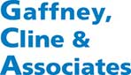
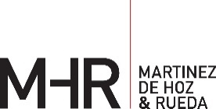

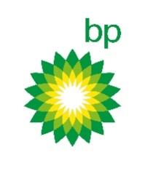
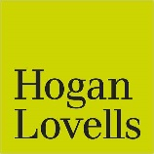
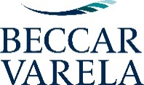
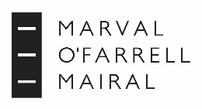

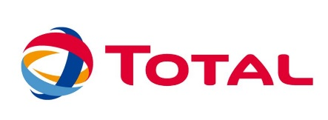
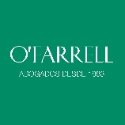
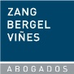
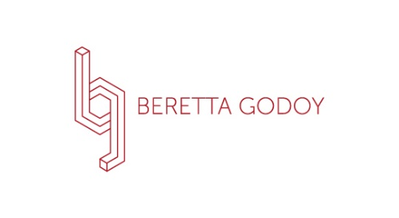
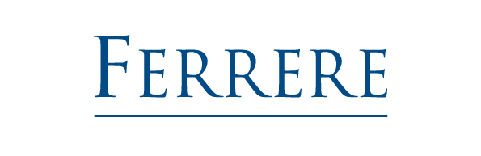
SILVER LEVEL CONFERENCE SPONSORS

